**NEURAL NETWORK ASSIGNMENT**

**Business Problem** = ﻿Prepare a model for strength of concrete data using Neural Networks.

* **Name of the File: -** concrete.csv
* **Size of the File: -** 45 KB
* **Data: -** 1030 Observation, 9 Variable

**Exploratory data Analysis** =

* **Outliers: -**  Profit variable having outliers.
* **Missing Value: -** Data don’t have Missing Values
* **Normality: -** Data are near normal

**Scatter plot =**

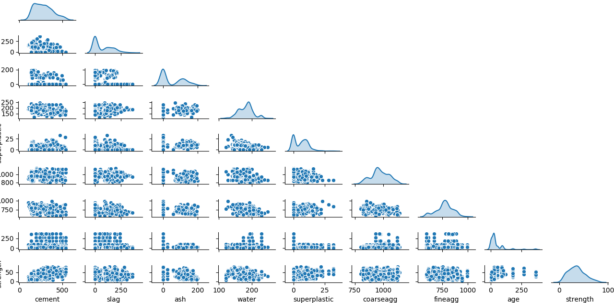

**Correlation Coefficient (r) =**

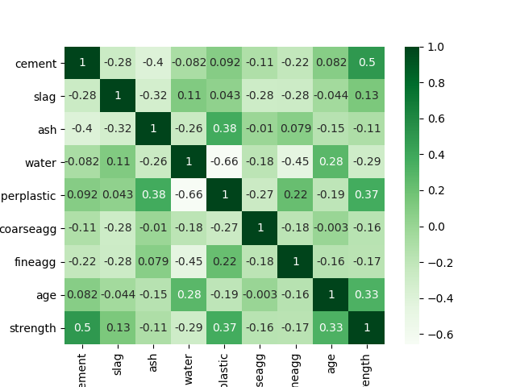

**Model ANN Building =** Building model by considering following parameters.

* **﻿Activation :-** Relu
* **﻿Neurons :-** 100
* **Epochs-** 172

**Accuracy of Model =**

* **Accuracy Train : -** 96%
* **Accuracy Test : -** 95%
* **RMSE Train : -** 23
* **RMSE Test :-** ﻿23

**Python code file**: - [Concrete Analysis.py](https://github.com/nilaydeshmukh0/Artificial-Neural-Network/blob/master/Concrete%20Analysis/Concrete%20Analysis.py)